ASSIGNMENT 4

1)
#include <iostream>
using namespace std;

#define MAX 10

class Queue {
private:
int arr[MAX];
int front;
int rear;

public:
Queue() {
front = -1;
rear = -1;
}

// Enqueue
void enqueue(int value) {
if (rear == MAX - 1) {
cout << "Queue is Full!" << endl;
} else {
if (front == -1) {
front = 0; // If the queue is empty, set front to 0
}
rear++;
arr[rear] = value;
cout << "Enqueued " << value << endl;
}
}

// Dequeue
void dequeue() {
if (front == -1 || front > rear) {
cout << "Queue is Empty!" << endl;
} else {
cout << "Dequeued " << arr[front] << endl;
front++;
}
}
bool isEmpty() {
return (front == -1 || front > rear);
}
bool isFull() {
return (rear == MAX - 1);
}

void display() {
if (isEmpty()) {
cout << "Queue is Empty!" << endl;
} else {
cout << "Queue elements: ";
for (int i = front; i <= rear; i++) {
cout << arr[i] << " ";
}
cout << endl;
}
}

// Peek (front element)
void peek() {
if (isEmpty()) {
cout << "Queue is Empty!" << endl;
} else {
cout << "Front element: " << arr[front] << endl;
}
}
};

int main() {
Queue q;
int choice, value;
do {
cout << "\nQueue Operations Menu" << endl;
cout << "1. Enqueue" << endl;
cout << "2. Dequeue" << endl;
cout << "3. Check if Queue is Empty" << endl;
cout << "4. Check if Queue is Full" << endl;
cout << "5. Display Queue" << endl;
cout << "6. Peek (view front element)" << endl;
cout << "7. Exit" << endl;
cout << "Enter your choice: ";
cin >> choice;
switch (choice) {
case 1:
cout << "Enter value to enqueue: ";
cin >> value;
q.enqueue(value);
break;
case 2:
q.dequeue();
break;
case 3:
if (q.isEmpty())
cout << "Queue is Empty!" << endl;
else
cout << "Queue is not Empty!" << endl;
break;
case 4:
if (q.isFull())
cout << "Queue is Full!" << endl;
else
cout << "Queue is not Full!" << endl;
break;
case 5:
q.display();
break;
case 6:
q.peek();
break;
case 7:
cout << "Exiting program." << endl;
break;
default:
cout << "Invalid choice! Please try again." << endl;
}
} while (choice != 7);
return 0;
}
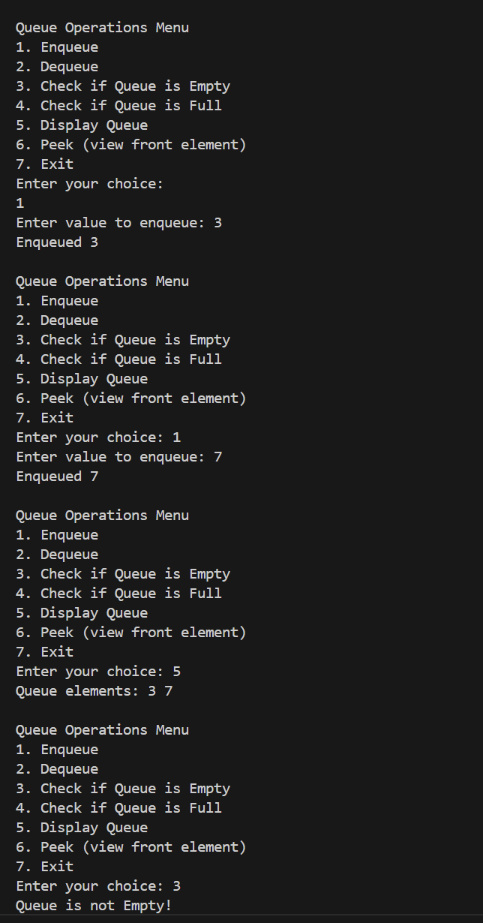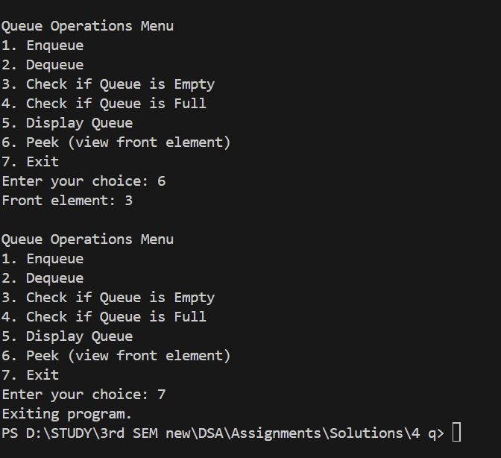

2) #include <iostream>
using namespace std;

#define MAX 5

class CircularQueue {
private:
int arr[MAX];
int front;
int rear;

public:
CircularQueue() {
front = -1;
rear = -1;
}

// Enqueue
void enqueue(int value) {
if ((rear + 1) % MAX == front) {
cout << "Queue is Full!" << endl;
} else {
if (front == -1) {
front = 0;
}
rear = (rear + 1) % MAX;
arr[rear] = value;
cout << "Enqueued " << value << endl;
}
}

// Dequeue
void dequeue() {
if (front == -1) {
cout << "Queue is Empty!" << endl;
} else {
cout << "Dequeued " << arr[front] << endl;
if (front == rear) {
front = rear = -1;
} else {
front = (front + 1) % MAX;
}
}
}

bool isEmpty() {
return (front == -1);
}

bool isFull() {
return ((rear + 1) % MAX == front);
}

void display() {
if (isEmpty()) {
cout << "Queue is Empty!" << endl;
} else {
cout << "Queue elements: ";
int i = front;
while (i != rear) {
cout << arr[i] << " ";
i = (i + 1) % MAX;
}
cout << arr[rear] << endl;
}
}

// Peek
void peek() {
if (isEmpty()) {
cout << "Queue is Empty!" << endl;
} else {
cout << "Front element: " << arr[front] << endl;
}
}
};

int main() {
CircularQueue q;
int choice, value;

do {
cout << "\nCircular Queue Operations Menu" << endl;
cout << "1. Enqueue" << endl;
cout << "2. Dequeue" << endl;
cout << "3. Check if Queue is Empty" << endl;
cout << "4. Check if Queue is Full" << endl;
cout << "5. Display Queue" << endl;
cout << "6. Peek (view front element)" << endl;
cout << "7. Exit" << endl;
cout << "Enter your choice: ";
cin >> choice;

switch (choice) {
case 1:
cout << "Enter value to enqueue: ";
cin >> value;
q.enqueue(value);
break;
case 2:
q.dequeue();
break;
case 3:
if (q.isEmpty())
cout << "Queue is Empty!" << endl;
else
cout << "Queue is not Empty!" << endl;
break;
case 4:
if (q.isFull())
cout << "Queue is Full!" << endl;
else
cout << "Queue is not Full!" << endl;
break;
case 5:
q.display();
break;
case 6:
q.peek();
break;
case 7:
cout << "Exiting program." << endl;
break;
default:
cout << "Invalid choice! Please try again." << endl;
break;
}
} while (choice != 7);

return 0;
}

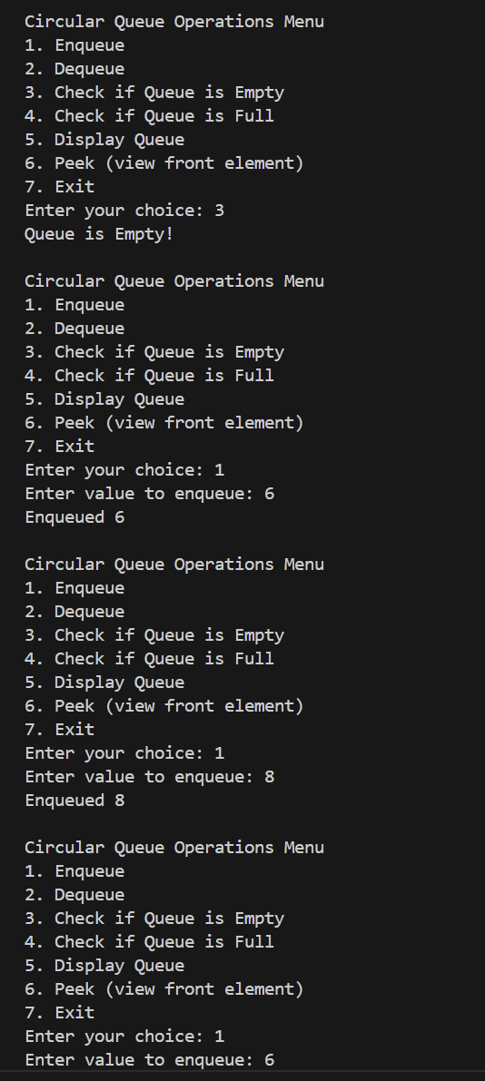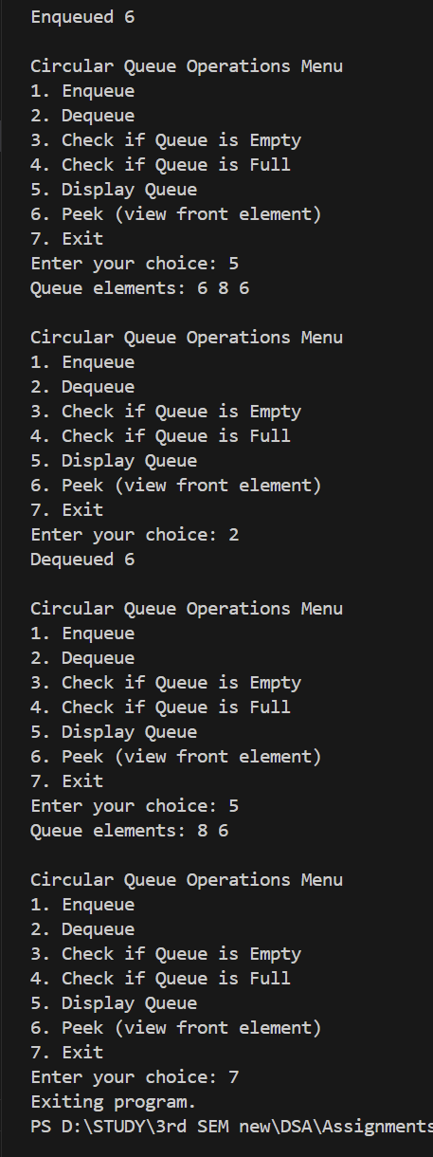

3)
#include <iostream>
using namespace std;

#define MAX 10
class Queue {
private:
int arr[MAX];
int front;
int rear;

public:
Queue() {
front = -1;
rear = -1;
}
void enqueue(int value) {
if (rear == MAX - 1) {
cout << "Queue is Full!" << endl;
} else {
if (front == -1) {
front = 0;
}
rear++;
arr[rear] = value;
}
}
void dequeue() {
if (front == -1 || front > rear) {
cout << "Queue is Empty!" << endl;
} else {
front++;
}
}

void display() {
if (front == -1 || front > rear) {
cout << "Queue is Empty!" << endl;
} else {
cout << "Queue elements: ";
for (int i = front; i <= rear; i++) {
cout << arr[i] << " ";
}
cout << endl;
}
}
void interleave() {
if ((rear - front + 1) % 2 != 0) {
cout << "Queue size is odd, cannot interleave!" << endl;
return;
}

int size = rear - front + 1;
int mid = size / 2;
int firstHalf[mid];
int secondHalf[mid];

for (int i = 0; i < mid; i++) {
firstHalf[i] = arr[front + i];
secondHalf[i] = arr[front + mid + i];
}

int i = 0, j = 0, k = front;
while (i < mid && j < mid) {
arr[k++] = firstHalf[i++];
arr[k++] = secondHalf[j++];
}

display();
}

int size() {
return rear - front + 1;
}
};

int main() {
Queue q;
int n;

cout << "Enter the number of elements in the queue (even number for interleaving): ";
cin >> n;

if (n % 2 != 0) {
cout << "Enter even number of elements!" << endl;
return 1;
}

cout << "Enter " << n << " elements for the queue: ";
for (int i = 0; i < n; ++i) {
int value;
cin >> value;
q.enqueue(value);
}

cout << "Original Queue: ";
q.display();

cout << "Interleaved Queue: ";
q.interleave();

return 0;
}
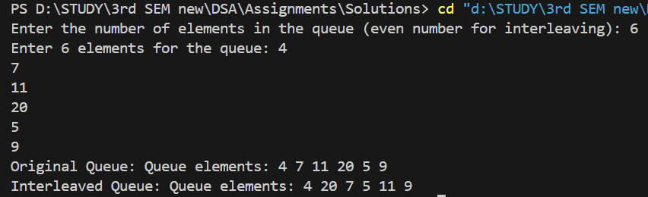

4) #include <iostream>
using namespace std;
#define MAX_CHAR 32

void firstNonRepeating(string str) {
int freq[MAX_CHAR] = {0};
char queue[1000];
int front = 0, rear = 0;
for (int i = 0; i < str.length(); i++) {
char current = str[i];

freq[current]++;

if (freq[current] == 1) {
queue[rear] = current;
rear++;
}
while (front < rear && freq[queue[front]] > 1) {
front++;
}
if (front < rear) {
cout << queue[front] << " ";
} else {
cout << "-1 ";
}
}
cout << endl;
}
int main() {
string str;
cout << "Enter a string: ";
cin >> str;
firstNonRepeating(str);

return 0;
}
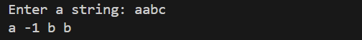
5)a) #include <iostream>
using namespace std;

class StackUsingTwoQueues {
int q1[100], q2[100];
int front1, rear1, front2, rear2;

public:
StackUsingTwoQueues() {
front1 = rear1 = front2 = rear2 = 0;
}

void push(int x) {
q1[rear1++] = x;
cout << x << " pushed to stack." << endl;
}

void pop() {
if (front1 == rear1) {
cout << "Stack is empty!" << endl;
return;
}

while (front1 < rear1 - 1) {
q2[rear2++] = q1[front1++];
}

front1++;
swap(front1, front2);
swap(rear1, rear2);

cout << "Element popped from stack." << endl;
}
int top() {
if (front1 == rear1) {
cout << "Stack is empty!" << endl;
return -1;
}
while (front1 < rear1 - 1) {
q2[rear2++] = q1[front1++];
}
int topElem = q1[front1];
q2[rear2++] = topElem;
swap(front1, front2);
swap(rear1, rear2);

return topElem;
}
bool isEmpty() {
return front1 == rear1;
}
};

int main() {
StackUsingTwoQueues stack;
int choice, value;

while (true) {
cout << "\n--- Stack Using Two Queues ---\n";
cout << "1. Push an element\n";
cout << "2. Pop an element\n";
cout << "3. Display top element\n";
cout << "4. Check if stack is empty\n";
cout << "5. Exit\n";
cout << "Enter your choice: ";
cin >> choice;

switch (choice) {
case 1:
cout << "Enter value to push: ";
cin >> value;
stack.push(value);
break;
case 2:
stack.pop();
break;
case 3:
cout << "Top element: " << stack.top() << endl;
break;
case 4:
if (stack.isEmpty()) {
cout << "Stack is empty!" << endl;
} else {
cout << "Stack is not empty!" << endl;
}
break;
case 5:
cout << "Exiting...\n";
return 0;
default:
cout << "Invalid choice! Please try again.\n";
}
}
}

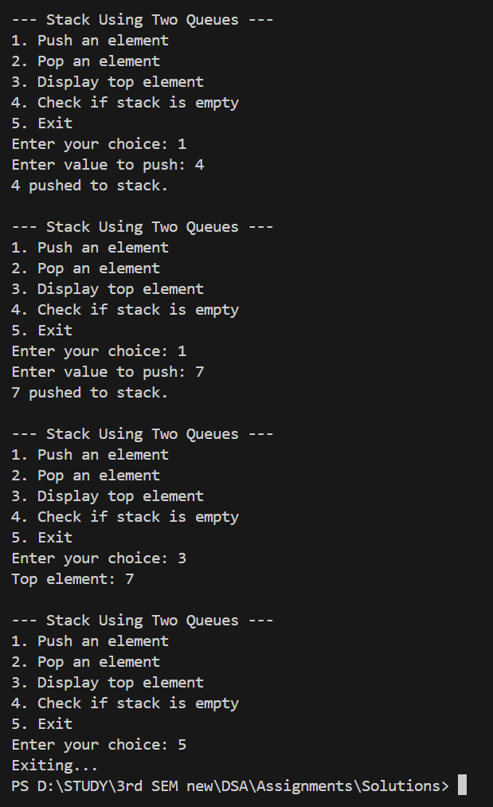
5)b) #include <iostream>
using namespace std;

class StackUsingOneQueue {
int q[100];
int front, rear;

public:
StackUsingOneQueue() {
front = rear = 0;
}

void push(int x) {
int size = rear - front;

q[rear++] = x;

for (int i = 0; i < size; i++) {
q[rear++] = q[front++];
}

cout << x << " pushed to stack." << endl;
}

void pop() {
if (front == rear) {
cout << "Stack is empty!" << endl;
return;
}
front++;
cout << "Element popped from stack." << endl;
}

int top() {
if (front == rear) {
cout << "Stack is empty!" << endl;
return -1;
}
return q[front];
}

bool isEmpty() {
return front == rear;
}
};

int main() {
StackUsingOneQueue stack;
int choice, value;

while (true) {
cout << "\n--- Stack Using One Queue ---\n";
cout << "1. Push an element\n";
cout << "2. Pop an element\n";
cout << "3. Display top element\n";
cout << "4. Check if stack is empty\n";
cout << "5. Exit\n";
cout << "Enter your choice: ";
cin >> choice;

switch (choice) {
case 1:
cout << "Enter value to push: ";
cin >> value;
stack.push(value);
break;
case 2:
stack.pop();
break;
case 3:
cout << "Top element: " << stack.top() << endl;
break;
case 4:
if (stack.isEmpty()) {
cout << "Stack is empty!" << endl;
} else {
cout << "Stack is not empty!" << endl;
}
break;
case 5:
cout << "Exiting...\n";
return 0;
default:
cout << "Invalid choice! Please try again.\n";
}
}
}

